Brainstorm

& idea prioritization

Use this template in your own brainstorming sessions so your team can unleash their imagination and start shaping concepts even if you're not sitting in the same room.

## Before you collaborate

#### A little bit of preparation goes a long way with this session. Here’s what you need to do to get going.

**10 minutes**

1. **Team gathering**

Define who should participate in the session and send an invite. Share relevant information or pre-work ahead.

1. **Set the goal**

Think about the problem you'll be focusing on solving in the brainstorming session.

1. **Learn how to use the facilitation tools**

Use the Facilitation Superpowers to run a happy and

**1**

## Define your problem statement

#### What problem are you trying to solve? Frame your problem as a How Might We statement. This will be the focus of your brainstorm.

**5 minutes**

**PROBLEM**

To prevent from industrial hazadrous

**2**

## Brainstorm

#### Write down any ideas that come to mind that address your problem statement.

**10 minutes**

**Person 1**

**Internet of things aims to achieve higher operational and management efficiencies by machinery, equipment and all other actors involved in industrial environment these are the benefits of using IOT in project**

**In industrial plants**

**,there are some areas which are to be monitored hence we can avoid the hazardous in industrial plant**

**To avoid hazardous occurrence in industrial plant hazardous area monitoring for industrial plants help us**

**These monitoring device monitors the areas which should be monitored time to time**

**Person 2**

**The alerts are send to the monitoring person with location in a message format.**

**TIP**

You can select a sticky note and hit the pencil [switch to sketch] icon to start drawing!

# 

monitoring the industrial plant is done by integrating the smart devices in areas to be monitored

**Here in our project the sensors used to detect fire occurrence in industrial plant**

***Henceevery devicewillbe connectedto temperature sensorsandthese devicesactasa beacon***

**3**

## Group ideas

#### Take turns sharing your ideas while clustering similar or related notes as you go. Once all sticky notes have been grouped, give each cluster a sentence-like label. If a cluster is bigger than six sticky notes, try and see if you and break it up into smaller sub-groups.

**20 minutes**

**4**

## Prioritize

#### Your team should all be on the same page about what's important moving forward. Place your ideas on this grid to determine which ideas are important and which are feasible.

**20 minutes**

**It help prevent the occurrence of explosion.**

## After you collaborate

You can export the mural as an image or pdf to share with members of your company who might find it helpful.

**Quick add-ons**

1. **Share the mural**

**Share a view link** to the mural with stakeholders to keep them in the loop about the outcomes of the session.

1. **Export the mural**

Export a copy of the mural as a PNG or PDF to attach to emails, include in slides, or save in your drive.

**These sensor can broadcast the temperature data with their location to the beacon the beacon is completely monitored by a person**

**Temperature detectors are used to avoid major explosion.**

**10 minutes** to prepare

**1 hour** to collaborate

**2-8 people** recommended

productive session.

[**Open article**](https://support.mural.co/en/articles/2113740-facilitation-superpowers)

### Key rules of brainstorming

To run an smooth and productive session

**These can be termed as accident or incident according to the occurred loss**

**sensors are key components to detect the problem in industrial plant as we are detecting the explosion we use temperature sensor**

**The first step is to understand and defining the problem occurred due to explosion and fire**

**Person 3**

# 

**Industrial accidents are as old as industry itself and so are preventive measures**

**Explosion and fire are two major constituents of these mishaps**

**Person 4**

# 

**The Hazard monitoring system are used to minimize the risk of explosions.**

**Sensors are accessed remotely and users can tolerate to generate alert in case of error.**

### It helps to prevent the hazardous that occurs due to fire and explosion.

**It sends the message with location hence the worker can easily detect the area that has fire.**

**it help us to detect the rise in temperature in industry and we can see the actual problem of the fire occurrence**

### Keep moving forward

**Strategy blueprint**

Define the components of a new idea or strategy.

[**Open the template**](https://app.mural.co/template/e95f612a-f72a-4772-bc48-545aaa04e0c9/984865a6-0a96-4472-a48d-47639307b3ca)

**Customer experience journey map**

Understand customer needs, motivations, and obstacles for an experience.

Stay in topic.

Defer judgment.

Encourage wild ideas.

Listen to others.

### Importance

If each of these

[**Open the template**](https://app.mural.co/template/b7114010-3a67-4d63-a51d-6f2cedc9633f/c1b465ab-57af-4624-8faf-ebb312edc0eb)

Go for volume. If possible, be visual.

tasks could get done without any difficulty or cost, which would have the most positive impact?

**Strengths, weaknesses, opportunities & threats**

Identify strengths, weaknesses, opportunities, and threats (SWOT) to develop a plan.

it detects fire wile the temperature is getting high when it detects then the workers will be safeguard at starting itself

|  |  |
| --- | --- |
|  |  |
|  |  |

[**Open the template**](https://app.mural.co/template/6a062671-89ee-4b76-9409-2603d8b098be/ca270343-1d54-4952-9d8c-fbc303ffd0f2)

[**Share template feedback**](https://muralco.typeform.com/to/CiqaHVat?typeform-source=app.mural.co)

**m**

**These prevent the industry fro unwanted expenses.**

**It ensures the safety of the equipment temperature and workers safety.**

[**Share template feedback**](https://muralco.typeform.com/to/CiqaHVat?typeform-source=app.mural.co)

### Feasibility

Regardless of their importance, which tasks are more feasible than others? (Cost, time, effort, complexity, etc.)

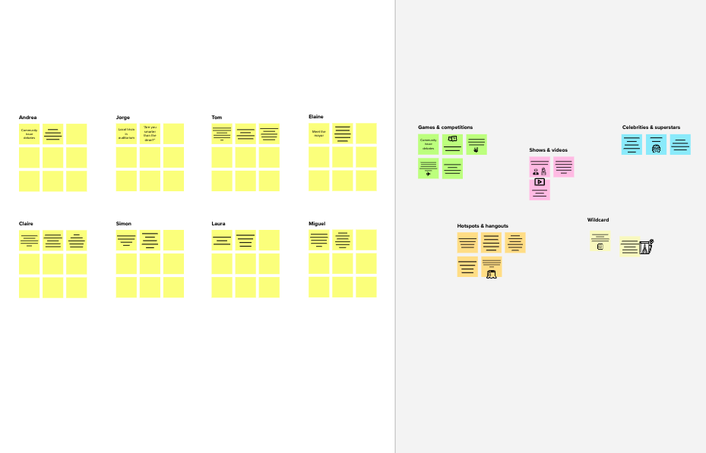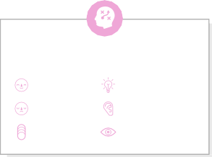

**Internet of things help us to make our tasks simpler.**

**it avoid the occurrence of hazardous due to fire**

**We used iot to make a temperature detector for industries.**

**To get notifed the monitoring person wear some wearable devices.**

**Temperature detector suddenly acces the rise in temperature.**

**After detecting the high temperature the notification to the beacon with location.**

**Template**

**Need some inspiration?**

See a finished version of this template to kickstart your work.

[**Open example**](https://app.mural.co/template/e5a93b7b-49f2-48c9-afd7-a635d860eba6/93f1b98d-b2d2-4695-8e85-7e9c0d2fd9b9)